Simulation Parameters:

* Initial Number of Miners.
* Initial Number of Machines per Miner.
* Initial Block Creation Time of one Machine – the average time in minutes that takes to one miner to solve a puzzle.
* Difficulty adjustment mechanism algorithm parameters:
  + Number of Blocks in one Window.
  + Maximal Fix Rate – the maximal change ratio in the difficulty factor after creation of a window of blocks.
  + Optimal Block Creation Time of the System – the average time in minutes of producing one new block in the system.

During the simulation random number of miners leave and join the system. In addition, number of miners that was chosen in advance leave and join the system.

1. **Window Size Effect**

The number of machines in the system is **constant** during the simulation.

|  |  |
| --- | --- |
| Initial Number of Miners | 20 |
| Initial Number of Machines per Miner | 1 |
| Initial Block Creation Time of one Machine | 100 minutes |
| Number of Blocks in one Window | 500 and 3000 |
| Maximal Fix Rate | 0.05 |
| Optimal Block Creation Time of the System | 10 minutes |

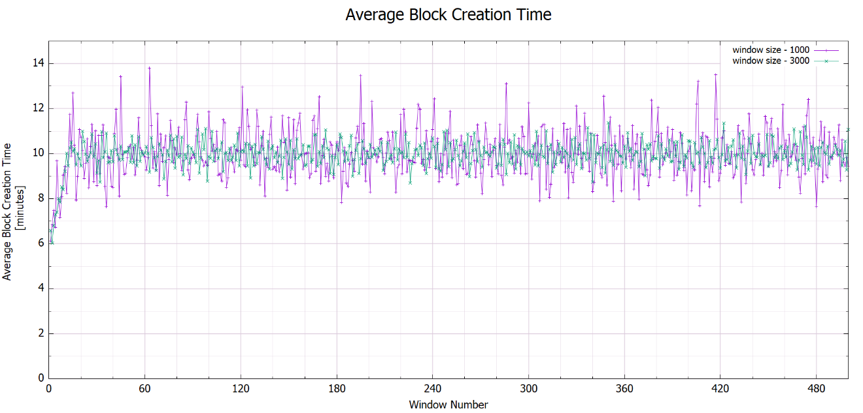

Figure 1 : Window size effect

1. **Max Fix Rate Effect**

The number of machines in the system is **constant** during the simulation.

|  |  |
| --- | --- |
| Initial Number of Miners | 20 |
| Initial Number of Machines per Miner | 1 |
| Initial Block Creation Time of one Machine | 100 minutes |
| Number of Blocks in one Window | 3000 |
| Maximal Fix Rate | 0.05 and 0.5 |
| Optimal Block Creation Time of the System | 10 minutes |

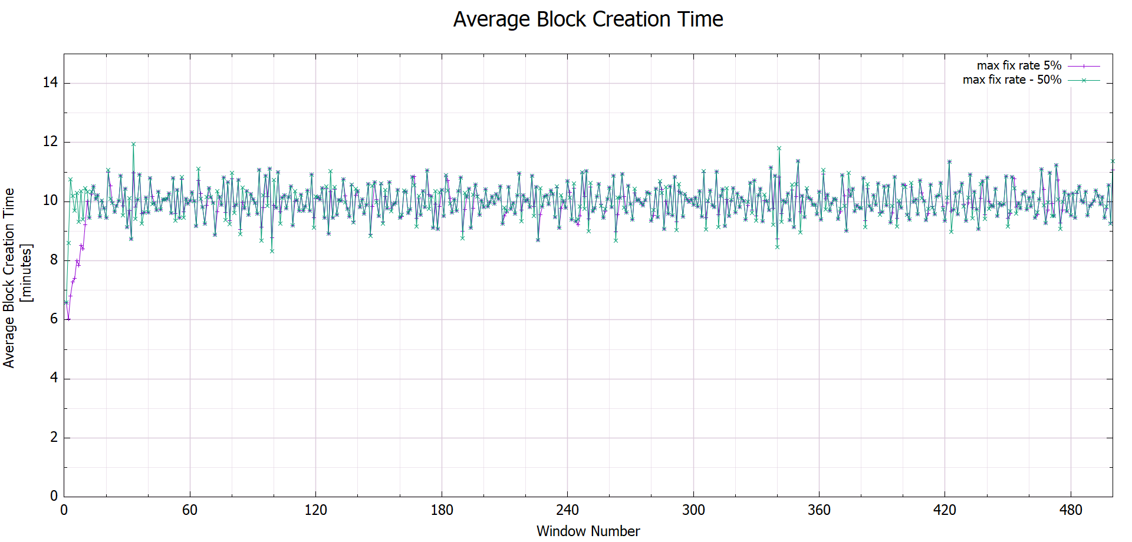

Figure 2: Maximal fix rate effect

1. **Scenario 1**

Changing the number of machines in the system:

|  |  |
| --- | --- |
| Simulation Time (minutes) | Machine Amount |
| 1505446 | 25 |
| 2927383 | -25 |
| 48334876 | 50 |
| 6435882 | -50 |

|  |  |
| --- | --- |
| Initial Number of Miners | 10 |
| Initial Number of Machines per Miner | 1 |
| Initial Block Creation Time of one Machine | 100 minutes |
| Number of Blocks in one Window | 2000 |
| Maximal Fix Rate | 0.05 |
| Optimal Block Creation Time of the System | 10 minutes |

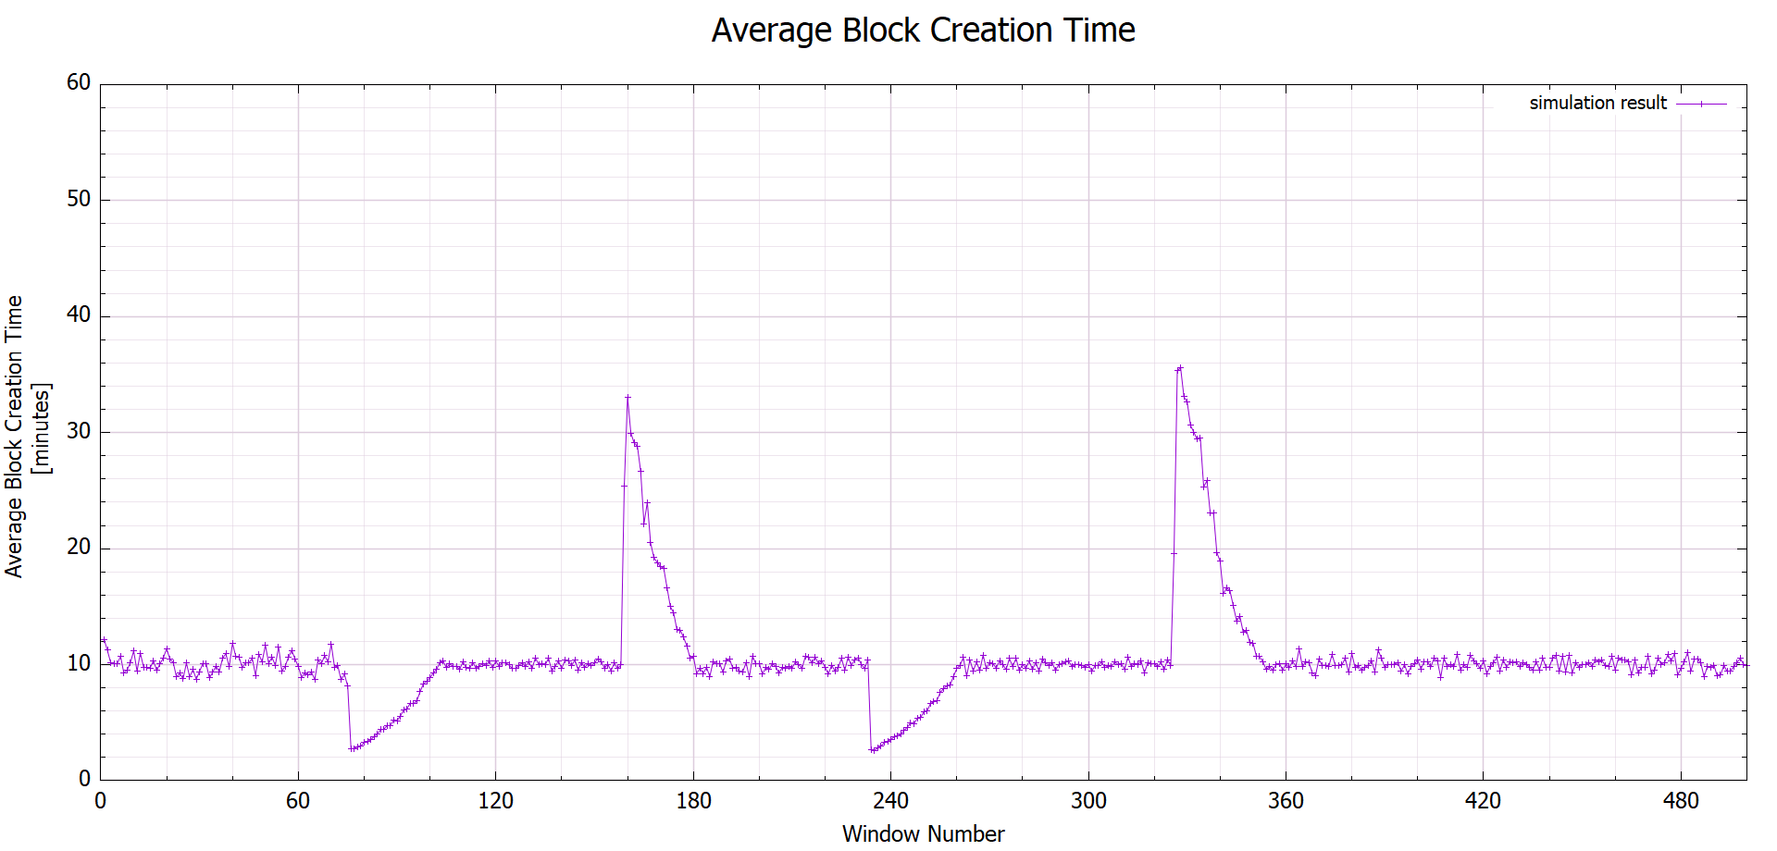

Figure 3: Scenario 1 - average block creation time vs window number

1. **Scenario 2**

|  |  |
| --- | --- |
| Simulation Time (minutes) | Machine Amount |
| 1505446 | 8000 |
| Simulation Time (minutes) | Machine Amount |
| 1505446 | -8000 |

|  |  |
| --- | --- |
| Initial Number of Miners | 20 |
| Initial Number of Machines per Miner | 1000 |
| Initial Block Creation Time of one Machine | 100 minutes |
| Number of Blocks in one Window | 2000 |
| Maximal Fix Rate | 0.05 |
| Optimal Block Creation Time of the System | 10 minutes |

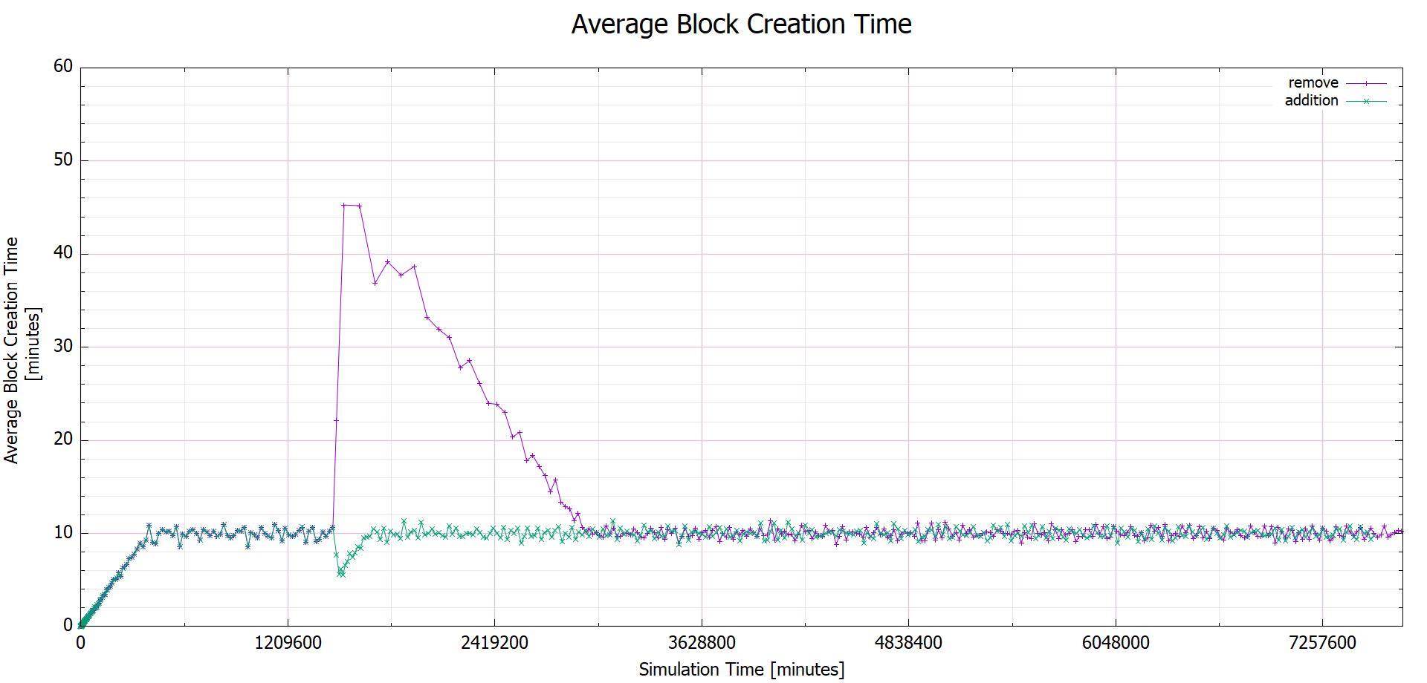

Figure 4: Scenario 2 - average block creation time vs simulation time

1. Scenario 3